Assignment 1 Report

By Ahmed Aboutaleb

# Part 1

**1)**

Nothing to mention.

**2)**

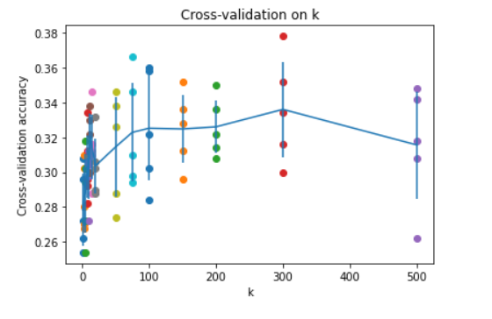

Chosen K = 300

**3)**

CCR of Tulips = 8%

CCR of Sunflower = 64%

CCR of Roses = 21%

CCR of Dandelion = 17%

CCR of Daisies = 35%

**4)**

ACCR for RGB = 29%

**5)**

ACCR for GreyScale = 24.6%.

* It gave a lower result than RGB

**1)**

Nothing to mention.

**2)**

Erms Vs Order of polynomial **(Orange: Training Set; Blue: Testing set)**

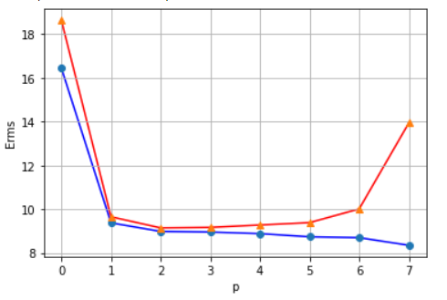

30 Data points where used, to give room for some error to occur in the testing set, before the error that arises in both sets (due to the precision of python). It is found that testing set’s Erms starts to increase a lot after the 6th order. Therefore 6th order is the best choice in this case.

**3)**

Erms Vs different inputs **(Orange: Testing Set; Blue: Training set)**

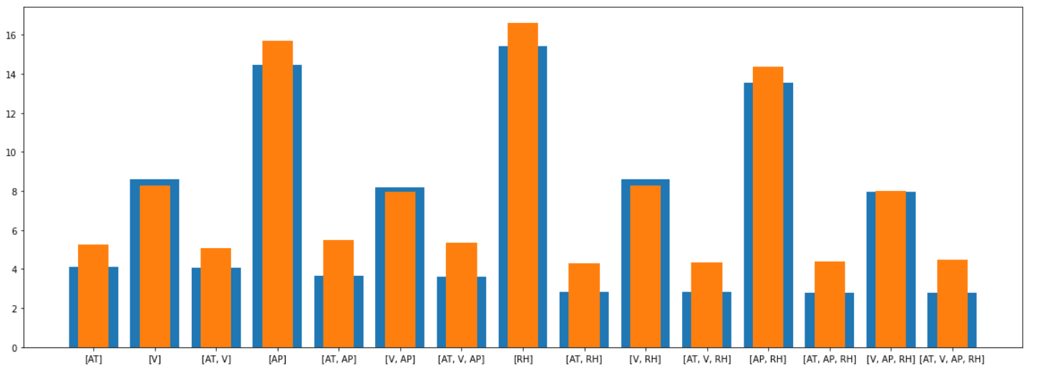

The results here make a lot of sense. Increasing the number of featres reduces the Erms generally.

**4)** Erms Vs Order of polynomial **(Orange: Training Set; Blue: Testing set)**

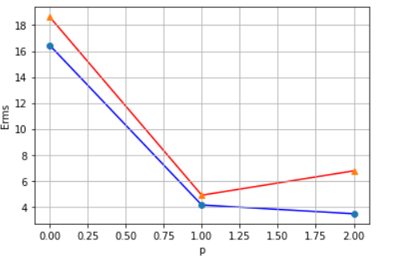

* 30 data points are used. The Erms for the testing set starts to increase from the quadratic form directly. Linear is the best.
* If more points are used, Both the training and the testing set’s Erms increase.
* Proposed reason: the precision of the programming language in calculating the weights is low.